# **Enplane iOS app Architecture**

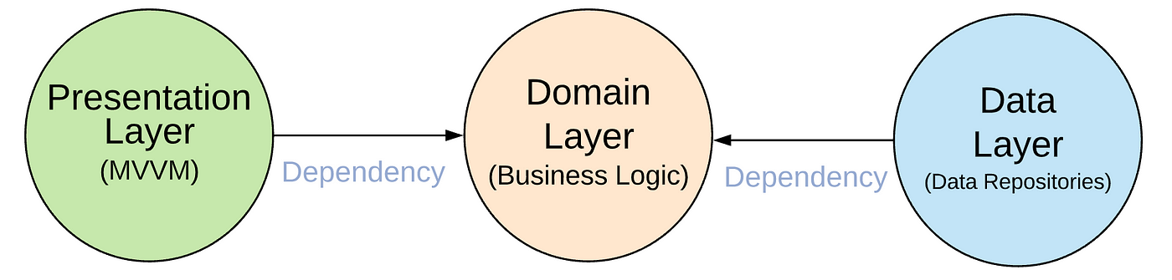



# **User Interface** / Presentation Layer:

**The presentation layer**contains *UI with the following options/components:*

* *UIKit – Storyboard, Code-based UI Development*
* *SwiftUI*
* *React Native UI components.*
* *View*
* *Presenters*
* *Pattern User – MV* (MVC, MVVM, MVP)*

*Views*are coordinated by *View Models (Presenters) which execute use cases to display for:*

* *User Details – Name, Billing Address, Email Address*
* *Betting Cart – Total Money, Place order, Cancel Order*
* *Bet Log*
* *Betting History*
* *Debit Card – Card Number, Issue, date of expiry, complete charge, reject charge*
* *Bet – Payout, odds, volume, type of bet*

# **Data Access Layer**

The data access layer help with communication with external systems and will be used for data and caching in *Core Data* or *User Defaults with the following components:*

* *Data Access Components*
* *Data helpers*
* *Service Agents*

Common Design Patterns:

* Gateway – Used to connect external systems like third-party integration – live streaming using different channels, PayPal and Payment Gateways
* Repository*- will be used for the database and web sources.*
* Domain Transfer Object *design patterns – Implemented using the codable struct*

# **Business Layer**

The business layer will have the following components:

* REST API Gateway
* Cache Provider
* Webhook handler
* WebSocket Gateway
* GraphQL Server

This layer will be used to run all the business layers to get the data and pass it to the presentation layer:

* Observer – to check for any update in the data.
* Observable
  + attach (observer)
  + detach (observer)
  + notify ()
  + gestate ()
* Bet Placer – to execute the bet.
* Bet Factory – to get the bet list
  + Live Match Bets List
  + Not Live Match Bets List
* Bets – Odds, type of Bet
  + Live Bet
  + Not Live Bet
* Odds Calculator – To calculate odds.

# **Third part Libraries:**

The app will some third-party libraries for integration some of the integrations:

* Live Streaming
* PayPal Payment
* Payment Gateway

**Security Layer:**

* Login Security



* Data protection classes
* Code Signing
* App Sandbox
* User encrypted data
* Device Key
* Apple root certificate on hardware

**Caching:**

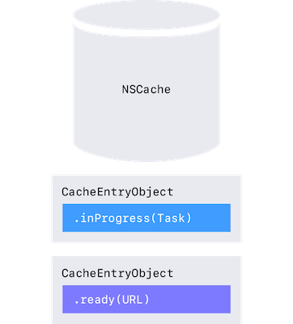

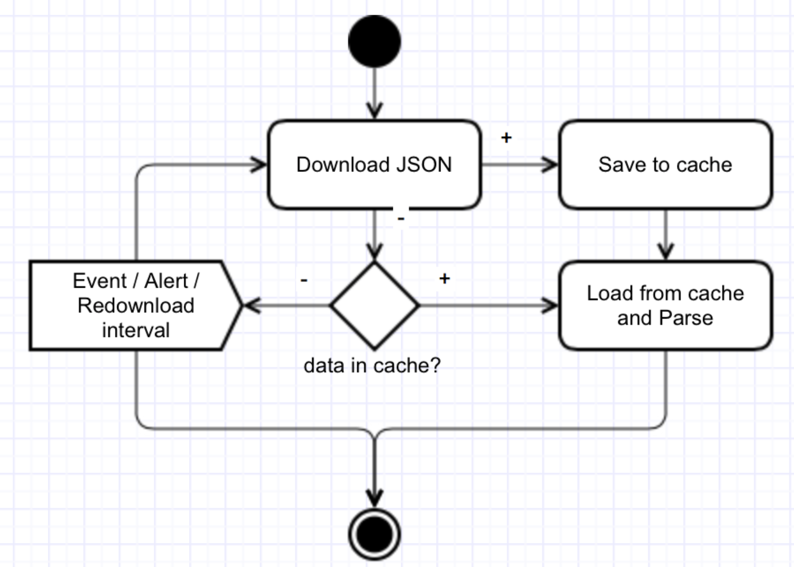

**GraphQL:**



**‘**

**Clean Architecture:**

